Relative Navigation

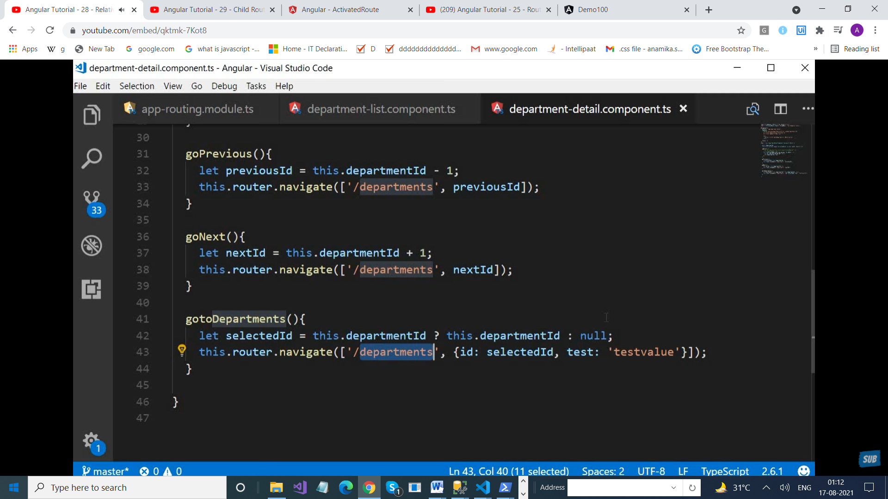

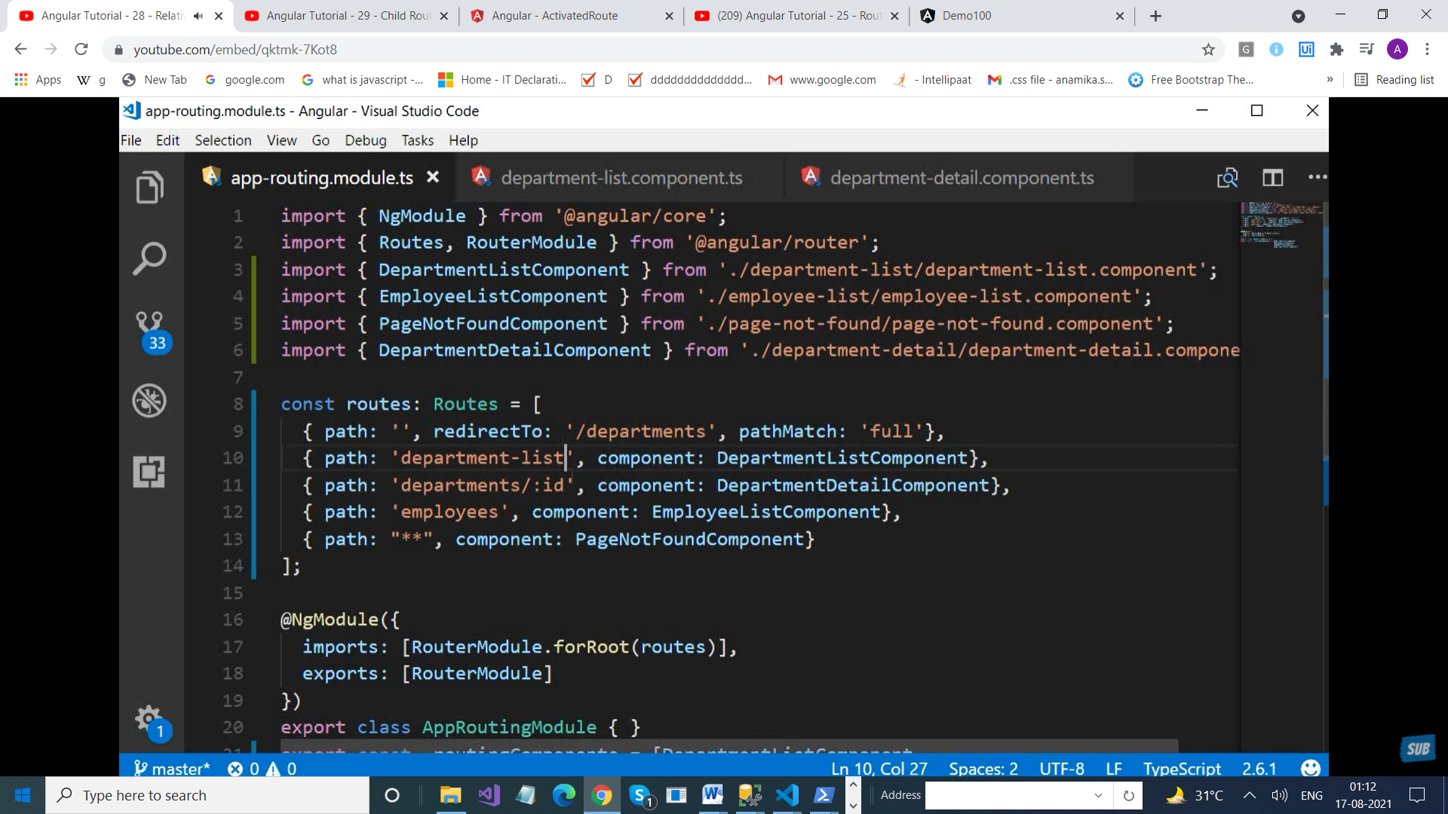

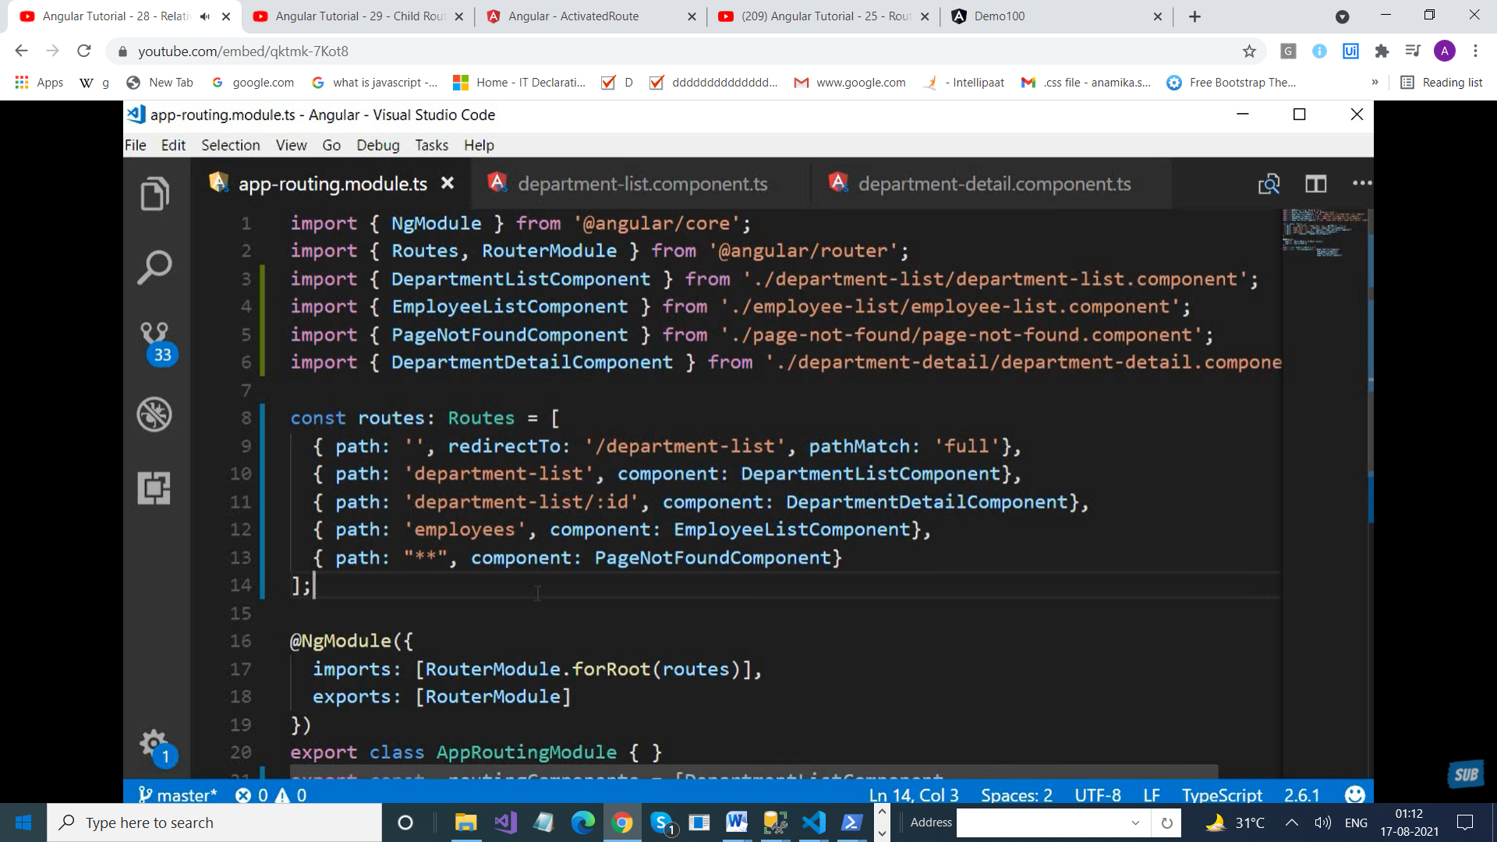

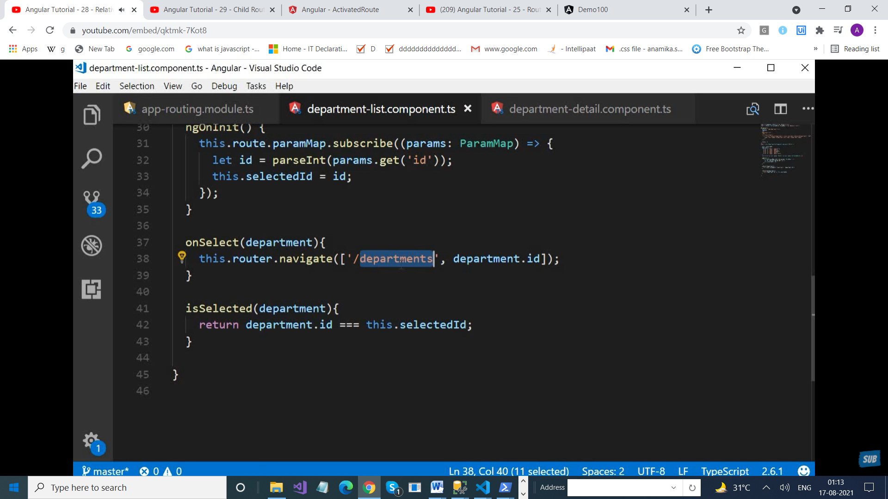

import { NgModule } from '@angular/core';

import { Routes, RouterModule } from '@angular/router';

import { EmployeeListComponent } from './employee-list/employee-list.component';

import { DepartmentListComponent } from './department-list/department-list.component';

import { NotFoundComponent } from './not-found/not-found.component';

import { combineLatest } from 'rxjs';

import { DepartmentDetailsComponent } from './department-details/department-details.component';

import { DepartmentOverviewComponent } from './department-overview/department-overview.component';

import { DepartmentContactComponent } from './department-contact/department-contact.component';

const routes: Routes = [

  {path:'', redirectTo: '/department-list', pathMatch:'full'},

  {path : 'department-list', component: DepartmentListComponent},

  {path: 'department-list/:id' , component:DepartmentDetailsComponent,

 children :[

   {path:'overview' ,component : DepartmentOverviewComponent},

   {path:'contact', component: DepartmentContactComponent}

 ]

  },

  {path: 'employees', component: EmployeeListComponent},

  {path:'**' , component:NotFoundComponent}

];

@NgModule({

  imports: [RouterModule.forRoot(routes)],

  exports: [RouterModule]

})

export class AppRoutingModule { }

export const routingComponents =[DepartmentListComponent,  EmployeeListComponent,  NotFoundComponent,

DepartmentListComponent];

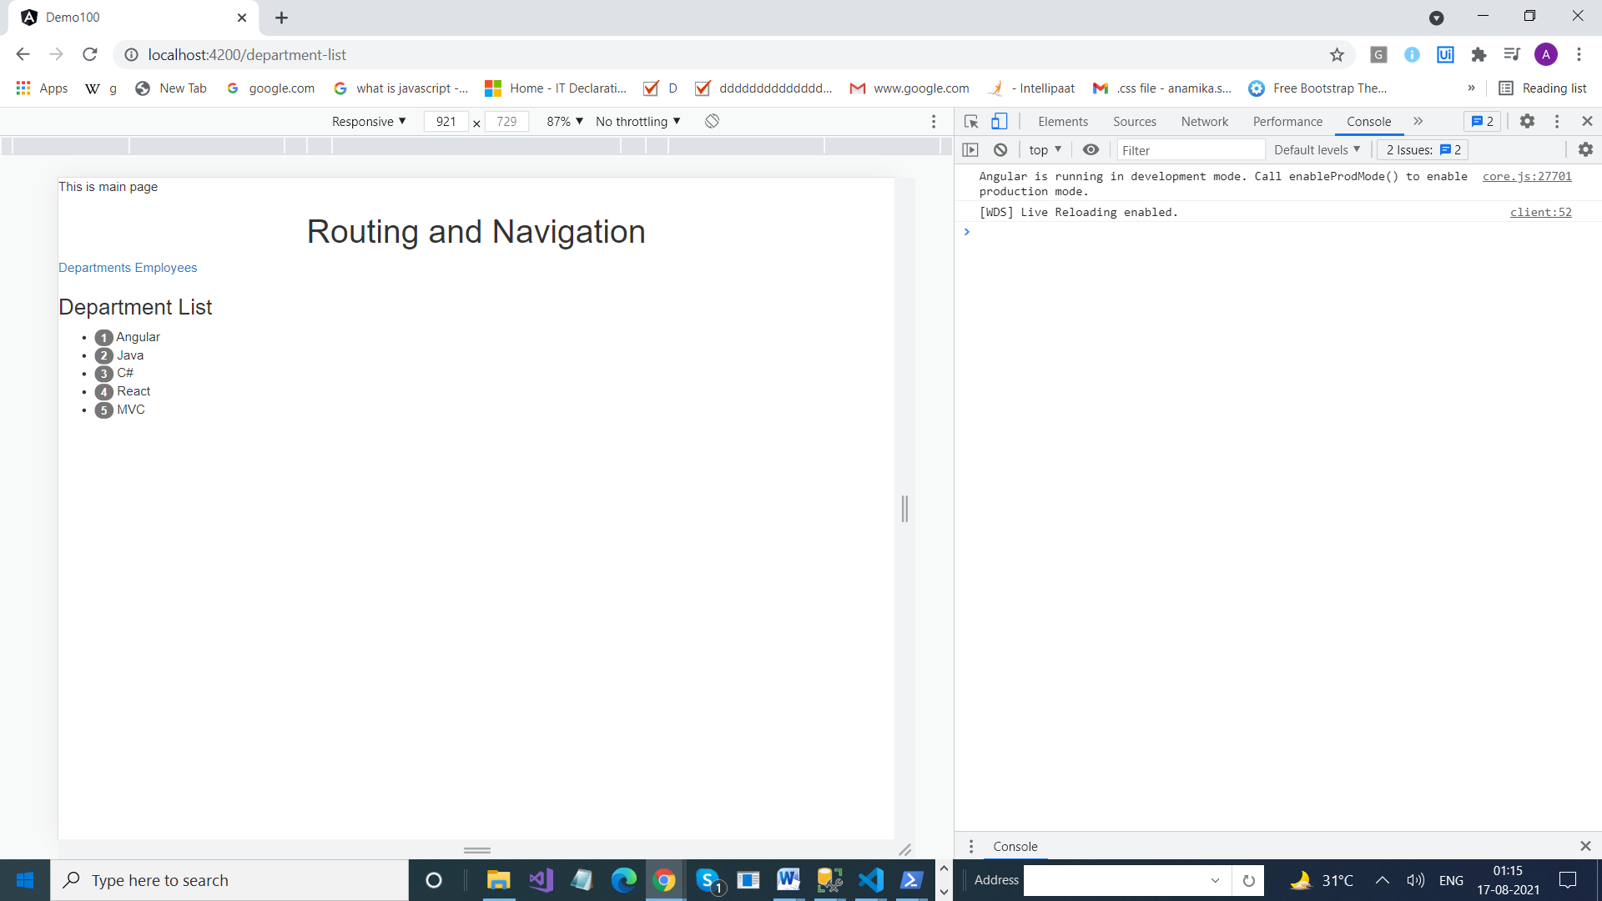

Not Working

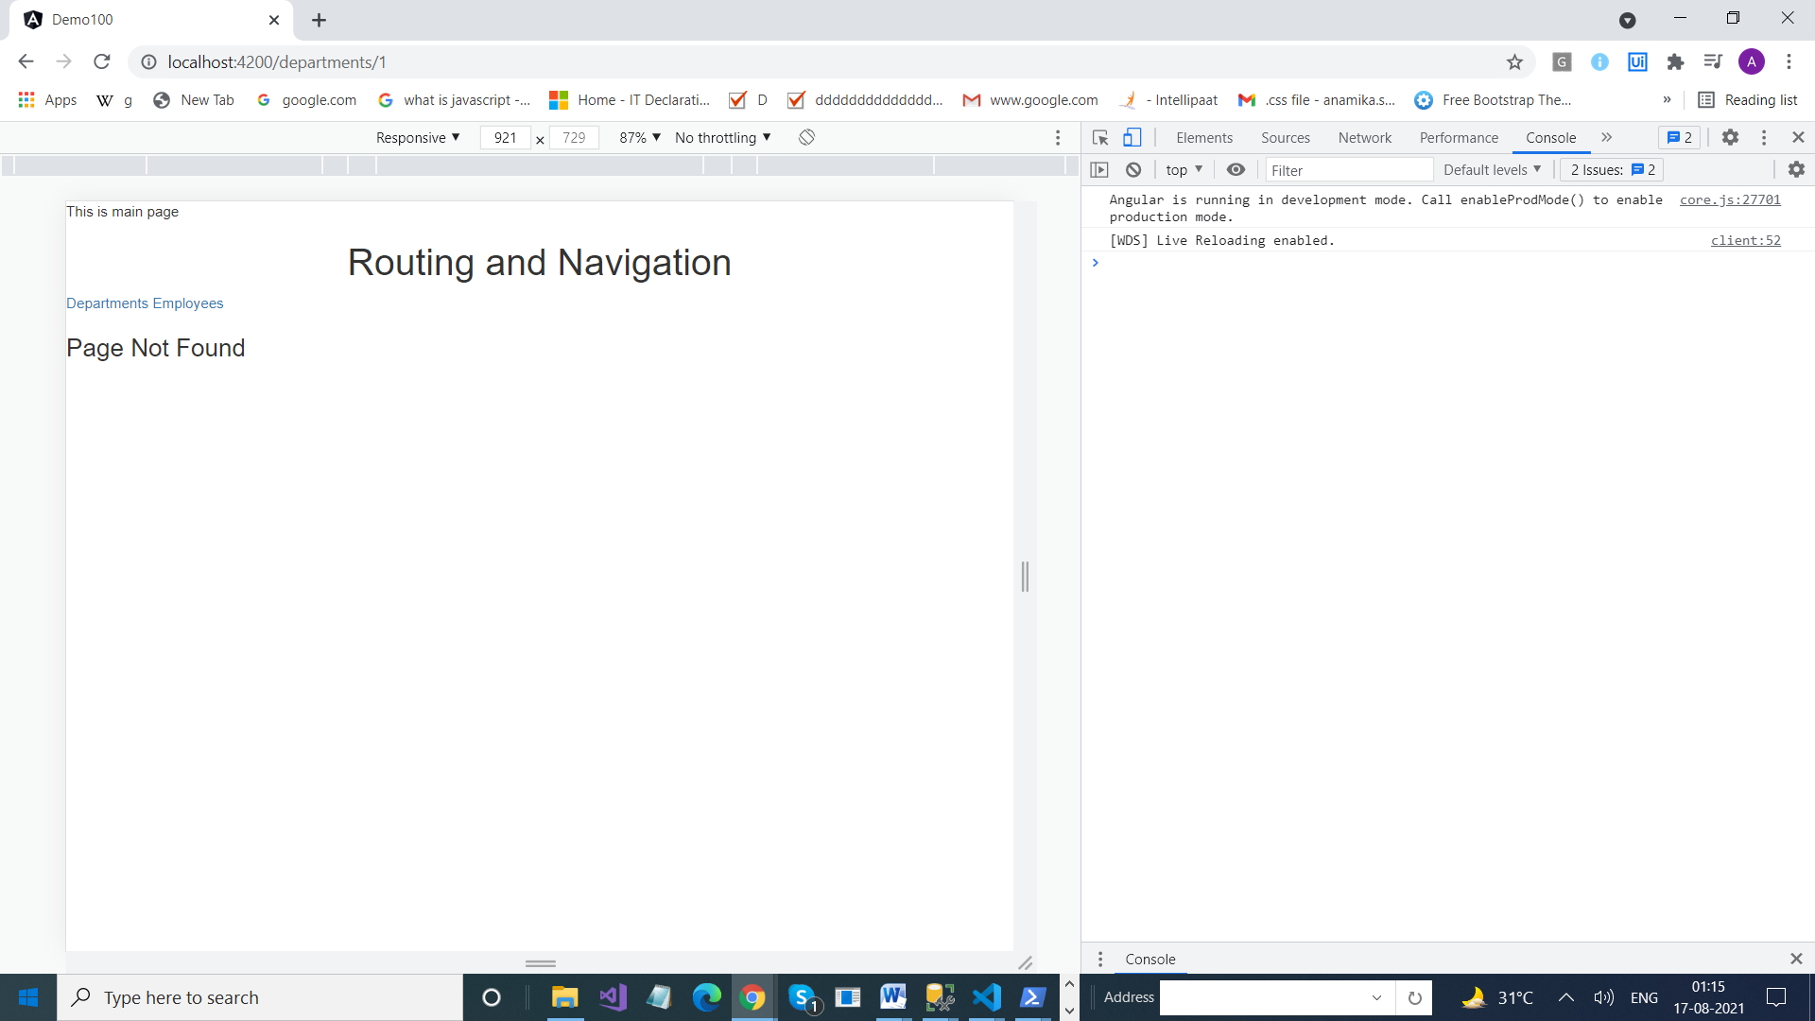

Change in DepartmentList

import {Router , ActivatedRoute} from '@angular/router';

 constructor(private _router : Router , private route : ActivatedRoute) { }

OnSelect(temp)

  {

    // this.router.navigate(['/departments', temp.id]);

    this.router.navigate([temp.id], {relativeTo: this.route});

  }